MiniProject Title: OrderMate

Subject: An All-in-One Business Mate with Invoicing, Inventory Management and Customer Data Storage for Small Business Owners.

# **I. Project Overview**

**OrderMate** is an Order Management System, a necessary asset for small businesses as it streamlines administrative tasks such as invoicing, inventory management, and customer data storage, allowing owners to focus on growing their business. It offers an all-in-one, user-friendly platform for small business owners, simplifying paperwork and daily operations.

According to an article by Process Street, managing an online marketplace can be challenging and an Order Management System can help streamline operations, improve inventory management, and increase efficiency.

(<https://www.process.st/online-marketplace/>)

Guidant Financial blog post states that small businesses face common problems like inventory and customer data management which can be solved by using OMS as an all-in-one solution.

(<https://www.guidantfinancial.com/blog/top-business-problems/>)

## The proposed project aims to address the problem of small business owners facing difficulties and wasting time on paperwork and administrative tasks such as invoicing, inventory management, and customer data storage.

## **A.** **Statement of the Problem**

## The proposed project aims to address the problem of small business owners with the following:

* What are common issues faced by business owners in effectively managing inventory levels?
* What are the challenges of manual data entry in terms of time management?
* What makes it difficult to track and monitor the performance of a business?
* Is the current OMS available in the market tailored to small business owners?

## 

## 

## **B.** **Project Solution**

* **OrderMates** can help business owners effectively manage their inventory levels by providing real-time insights, automating processes, and reducing manual errors.
* **Inventory visibility:** **OrderMates** provides a centralized view of all inventory across multiple channels and locations, making it easier to track inventory levels.
* **Efficient stock movements:** An OMS can automate many of the manual processes involved in stock movements, such as receiving, shipping, and transferring inventory, making them more efficient and accurate.
* Real-time tracking
* **OrderMates** can help address the challenges of manual data entry in terms of time management by automating manual processes, reducing data entry errors, and increasing overall efficiency and productivity.
* **Data accuracy:** An OMS provides real-time data accuracy, as data is entered once and automatically synced across all systems, reducing the risk of data inaccuracies that can occur with manual data entry.
* **Increased productivity**: OrderMates can streamline order management processes, allowing teams to process more orders in less time, resulting in increased productivity.
* **Improved efficiency:** By automating manual data entry processes, an OMS can significantly improve the overall efficiency of the order management process, freeing up time for other tasks.
* **OrderMates** can help address the difficulties in tracking and monitoring the performance of a business by providing real-time data, insights and reporting, centralized view, integration with other systems, and automating processes.
* **Real-time data:** provides real-time data on sales, inventory levels, customer demand, and order fulfillment, allowing business owners to quickly respond to changes in performance.
* **Insights and reporting**: generate reports and provide insights on key performance metrics such as sales, profit margins, and inventory turnover, helping business owners to better understand the performance of their business.
* **OrderMates** are tailored to small business owners and offer features that are specifically designed to meet their needs.
* **Affordable pricing**: designed to be affordable for small businesses, offering flexible pricing plans and cost-effective solutions.
* **User-friendly interface:** solutions for small businesses often have user-friendly interfaces, making it easier for non-technical users to use the system.
* **Integration with popular e-commerce platforms**: solutions for small businesses integrate with popular e-commerce platforms such as Lazada and Shopee, making it easier for small business owners to manage their orders and inventory.

# **II.** **System Features**

**Online billing**

Would allow them to generate and send invoices to their customers electronically. This would streamline the billing process, reducing the time and resources required for manual billing tasks.

**Online Store Feature**

Allows the seller to create and manage an online store to sell their products or services directly to customers. This would include setting up their store catalog, managing inventory, processing orders, and receiving payments. The seller would also have access to tools to manage the look and feel of their store, customize their checkout process, and analyze sales data to make informed business decisions.

**Stock management**

An orderMates feature that helps businesses keep track of their inventory levels, monitor stock movements, and ensure that they always have enough products or materials on hand to meet customer demand. This feature typically includes the ability to:

* **Monitor inventory levels:** Keep track of how much of each product or material the business has in stock, as well as how much is on order or on hold.
* **Update inventory records:** Automatically update inventory records in real-time as products are sold, restocked, or moved between locations.
* **Set reorder points:** Set reorder points for each product or material to ensure that the business never runs out of stock.

# **III.** **Limitations**

**OrderMates** is a software solution that helps businesses manage the complete order fulfillment process, from the time an order is placed to the time it is delivered. While OMS software can offer significant benefits, such as improved efficiency, accuracy, and visibility, it is not without its limitations. The following are some of the common challenges businesses face when implementing an OMS.

* **Data Security**: **OrderMate** stores sensitive customer and business data, and it is critical to ensure that the software has robust security measures in place to protect this information from breaches and unauthorized access.
* **Technical Issues**: An Order Management System is a complex software solution, and technical issues such as bugs, downtime, and system crashes can impact operations and disrupt business processes.
* **Integration**: **OrderMate** may not integrate well with other systems such as accounting software, warehouse management systems, and e-commerce platforms, which can result in data silos and manual data transfer.

# **IV.** **Theme, Fonts, logo, Technology used**

# **V.** **Site Map**

# 

# **VI.** **Mockup/Wireframe**

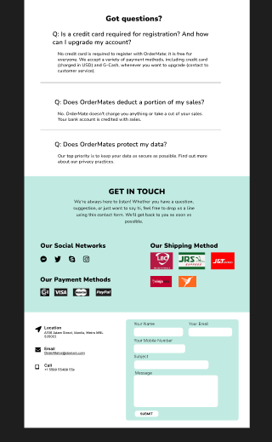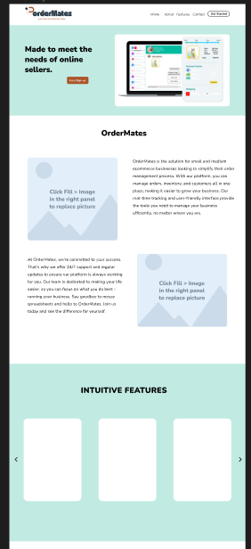

# **VII.** **Web App URL:**